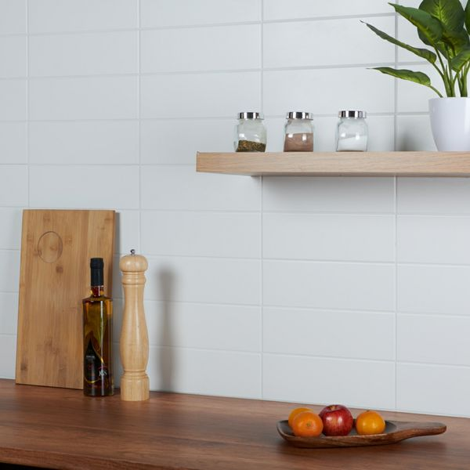**Linear White Matt Brick Tiles:**

## **Product Description**

Want to brighten up an interior area this season? These White Matt Linear Tiles are just what the doctor ordered. 300x100mm in size, these brick-shaped tiles are perfect for transforming bathroom and kitchen wall spaces. They have a flat surface, with a subtle matt finish. They belong to our range of stylish Linear Tiles. Want to try before you buy? Order yourself a sample tile. Samples come full-size and with Free Delivery!

## **Product Info**

* Product ID: 13921
* Tiles Per SQM: 33.333333333333
* Sale by: Per SQM
* Size: 300x100x7mm
* Weight: 0.40 KG
* Material Type: Ceramic
* Finish: Matt
* Colour: White
* Suitability: Walls
* Grade: No
* Rectified Edge: No
* Underfloor Heating: No
* Thickness (mm): 7